ROLLNUMBER ____________ SUBJECT CODE: 083
COIMBATORE SAHODAYA SCHOOLS COMPLEX
COMMON EXAMINATION DECEMBER 2019-20
Grade: XII COMPUTER SCIENCE Max. Marks: 70 Date : Time: 3 hrs
General Instructions:
All questions are compulsory.
Question Paper is divided into 4 sections A,B,C and D
Section A – Unit 1 Section B – Unit 2
Section C - Unit 3 Section D - Unit 4
SECTION A
Q1. | a) | What will be the output of the following expression? i) (5<10) and (10<5) or( 3<18) and not 8<18  ii) (17%5.0) is (17%5.0) | (1)
 | b) | Identify the types of following literals.  i) 0XFACE ii) “True” | (1)
 | c) | Name the Python Library module which needs to be imported to invoke the following functions.  i) floor() ii) dump() | (1)
 | d) | Rewrite the following code in Python after removing the Syntactical Error(s) if any . Underline each correction done.  def checkval:  x= input (“Enter a number”)  if x%2=0  print x,”is even”  else if x<0:  print x ,”should be positive”  else;  print x,”is odd” | (2)
 | e) | Find and write the output of the following Python code. 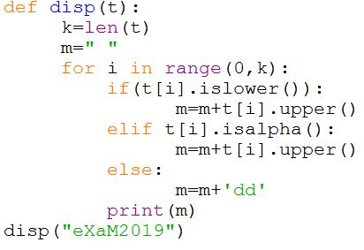 | (2)
 | f) | Find and write the output of the following Python Code.  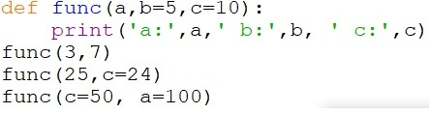 | (3)
 | g) | What possible outputs(s) are expected to be displayed on screen at the time of execution of the program from the following code? Also specify the minimum & maximum values that can be assigned to the variable Togo.  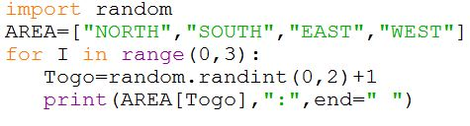  i) SOUTH:EAST:SOUTH: ii) NORTH:SOUTH:EAST:  iii) SOUTH:EAST:WEST: iv) SOUTH:EAST:EAST: | (2)
Q2. | a) | What is the difference between local and global variables in Python? | (1)
 | b) | Identify the wrong statements from the following options. State the reasons for the same.  i)D=[1,’hello’,7.8,9]  ii)E={(1,2,3):7,[6,7,8]:9,’well’:’done’}  iii)A=()  iv)B=”school”+5 | (1)
 | c) | Identify the valid declaration for M.  M=(5,7.9,[1,2,3],”water”)  i) List ii) String iii) Tuple iv) Dictionary | (1)
 | d) | Find and write the output of the following code:  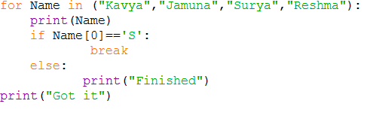 | (1)
 | e) | Predict the output of the following code fragment:  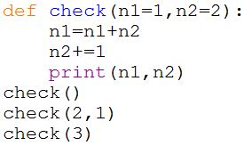 | (1)
 | f) | Identify the local, global, built in function and user defined function from the program code given below:  school = ‘Children’  class = 10  level = 3  def teach():  max_class=class+10  print(len(school)==0)  return max_class  res=teach()  print(res) | (2)
 | g) | Write Python code to create a pie for sequence con=[23.4,17.8,25,34,40] for Zones=[‘East’,’West’,’North’,’South’,’Central’]  - Show North zone’s value exploded  - Show % contribution for each zone  - The pie chart should be circular  OR  Give the output from the given python code:  import matplotlib.pyplot as plt;  plt.rcdefaults()  import numpy as np  import matplotlib.pyplot as plt  objects = ('Python', 'C++', 'Java', 'Perl', 'Scala', 'Lisp')  y_pos= np.arange(len(objects))  performance = [10,8,6,4,2,1]  plt.bar(y_pos, performance, align='center', alpha=0.5)  plt.xticks(y_pos, objects) plt.ylabel('Usage')  plt.title('Programming language usage')  plt.show() | (2)
 | h) | Write a function in Python to count the number of lowercase letters in a text file “Poem.txt”  OR  Write a function in Python to display those words which starts with an vowel from a text file “vowel.txt” | (2)
 | i) | Write a recursive function to compute greatest common divisor of two numbers.  OR  Write a Recursive function in python Binary Search (Arr,l,R,X) to search the given element X to be searched from the List Arr having R elements where l represents lower bound and R represents upper bound. | (3)
 | j) | Write a program to implement a stack for the book details (book no, book name). Implement Push and display operations  OR  Write functions in Python to perform insert and delete operations on a Queue containing Members details as given in the following definition of itemnode  MemberNo - integer  MemberName – string  Age - integer | (4)
 |  | SECTION B
Q3. |  | Questions 3(a) to 3 (d): Fill in the blanks
a) |  | _________is a device that can handle different protocols | (1)
b) |  | A set of technical rules that define how computers communicate over a network is called as _______ | (1)
c) |  | A specific condition that occurs when two or more nodes on a network transmit data at the same time is called as_____ | (1)
d) |  | _____________is a technology that connects the things to the Internet over wired or wireless connections. | (1)
e) |  | Give the full forms for the following.  i) SMTP ii) SSL  iii) FTP iv) Wi-Fi | (2)
f) | f) | State two differences between 2G and 4G | (2)
g) |  | Identify the type of cyber crimes from the following situations:  i) Sandeep’s personal or sensitive information is hacked by a hacker.  ii) Victims online activity is being monitored for a long time with the help of a malware  iii) A person complaints that his/her debit/credit card is safe with him still some body has done shopping/ATM transaction on this card. | (3)
h) |  | “Vidya For All” is an educational NGO. It is setting up its new campus at Jaipur for its web based activities. The campus has four buildings as shown in the diagram given below:  Resource Building  Main Building  Accounts Building  Training Building  Center to center distances between various buildings as per architectural drawings ( in meters) is as follows:  Main Building to Resource Building 120 m  Main Building to Training Building 40 m  Main Building to Accounts Building 135 m  Resource Building to Training Building 125 m  Resource Building to Accounts Building 45 m  Training Building to Accounts Building 110 m  Expected Number of Computers in each Building is as follows:  Main Building 15  Resource Building 25  Training Building 250  Accounts Building 10  i) Suggest a cable layout of connections between the buildings.  ii) Suggest the most suitable place (i.e. building) to house the server for this NGO. Also, provide a suitable reason for your suggestion.  iii) Suggest the placement of the following devices with justification:  a) Repeater  b) Hub / Switch  iv) The NGO is planning to connect its International office situated in Delhi. Which out of the following wired communication links, will you suggest for a very high speed connectivity?  a) Telephone Analog Line  b) Optical Fiber  c) Ethernet Cable | (4)
 |  | SECTION C
Q.4 | (a) | What is the clause used in SQL to specify the condition for which the records have to be displayed? | (1)
 | (b) | Which command is used to modify datas in a table? | (1)
 | (c) | Which command is used to delete a table? | (1)
 | (d) | Which clause is used to join the same datas and apply condition? | (1)
 | (e) | Write the differences between WHERE clause and HAVING clause of SQL SELECT statement. | (2)
 | (f) | Differentiate between Django GET and POST method | (2)
 | (g) | Write the output for SQL queries (i) to (iii), which are based on the table Coach.  Table: COACH  C_ID C_N AGE SPORTS APP PAY GENDER  1 KUKREJA 35 KARATE 27/03/1996 1000 M  2 RAVINA 34 KARATE 20/01/1998 1200 F  3 KARAN 34 SQUASH 19/02/1998 2000 M  4 TARUN 33 BASKETBALL 01/01/1998 1500 M  5 Zubin 36 SWIMMING 12/01/1998 750 M  6 KETAKI 36 SWIMMING 24/0/2/1998 800 F  7 ANKITA 39 SQUASH 20/02/1998 2200 F  8 ZAREEN 37 KARATE 22/02/1998 1100 F  9 KUSH 41 SWIMMING 13/01/1998 900 M | (3)
- SELECT COUNT(DISTINCT SPORTS) FROM COACH
ii) SELECT AVG(PAY) FROM COACH WHERE SPORTS =’KARATE’
iii) SELECT C_N, AGE AND SPORTS OF FEMALE COACHES.

 | (h) | Write SQL queries (i) to (iv) which are based on the table: COACH given in the question 4(g)  i) To display the records from table COACH in alphabetical order of the name.  ii) To display the name, age and sport of the coaches whose pay is more than 1000.  iii) To increase the pay of all Male coaches by 200  iv) To find the total pay of all the coaches. | (4)
 |  | SECTION D
 | a) | _________________is the act of using or stealing someone else’s intellectual wok, ideas and posing it as your own work | (1)
 | b) | Write any two benefits of e-Waste recycling. | (1)
 | c) | What is meant by computer forensics? | (2)
 | d) | What do you mean by shareware and open source software? | (2)
 | e) | What are the common gender and disability issues faced while teaching/using computers in classrooms? | (2)
 | f) | Mrinalini wanted to gift her friend a bracelet whose picture she saw in a photo sharing website that listed the design and cost of customization. She transferred an advanced payment of Rs.2450 to the account mentioned on the site and was promised a date of delivery. But to her shock her gift never arrived. Even after repeated calls, she only had a promise that it would be delivered soon and suddenly that website account was deleted from the photo sharing website and even the number went dead. Identify and explain the cyber crime discussed in the above scenario. | (2)

